**EXPERIMENT – 7**

**AIM :**

Write the queries to implement the Subqueries**.**

**THEORY :**

In this experiment we will see the implementation of Subqueries. Subqueries in database management systems (DBMS) are queries that are embedded within another query. A subquery, also known as a nested query or inner query, is used to retrieve data from one or more tables and provide the results as input to the outer query. The outer query then uses the results of the subquery to perform additional operations or comparisons

Here are a few key aspects of subqueries in DBMS:

**1. SYNTAX**: Subqueries are enclosed within parentheses and typically placed within the WHERE or HAVING clause of the outer query. The subquery can contain its own SELECT, FROM, WHERE, and other clauses.

**2. EXECUTION ORDER:** The DBMS executes the subquery first and uses its result as a temporary table. The outer query then operates on this temporary table to produce the final result.

**3. RELATIONSHIP WITH THE OUTER QUERY:** Subqueries are often used to filter or retrieve specific data based on certain conditions. The subquery's result is compared to values or columns in the outer query to determine the final result set.

**4. TYPES OF SUBQUERIES:**

* **SCALAR SUBQUERY:** Returns a single value as the result. It can be used in comparisons or calculations within the outer query.
* **SINGLE-ROW SUBQUERY:** Retrieves a single row of data and compares it with values in the outer query.
* **MULTIPLE-ROW SUBQUERY:** Returns multiple rows of data and can be used with operators like IN, ANY, or ALL in the outer query.
* **CORRELATED SUBQUERY:** The subquery refers to columns from the outer query, allowing for a more complex relationship between the two

**PROCEDURE :**

**GIVEN TABLES:**

**1. BORROW:**

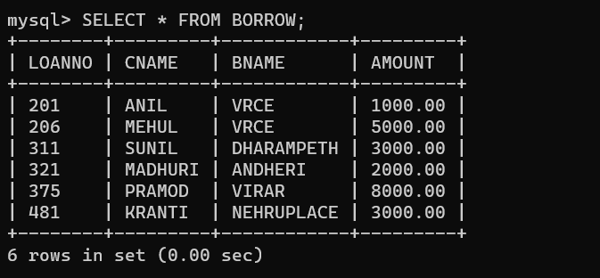

**2. CUSTOMERS:**

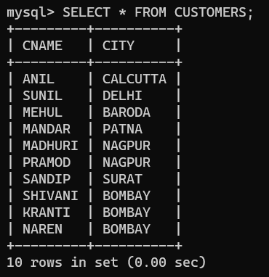

**3. BRANCH:**

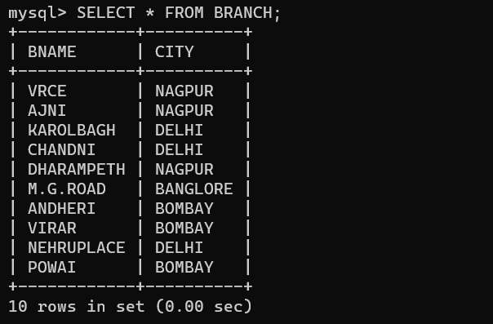

**4.DEPOSIT:**

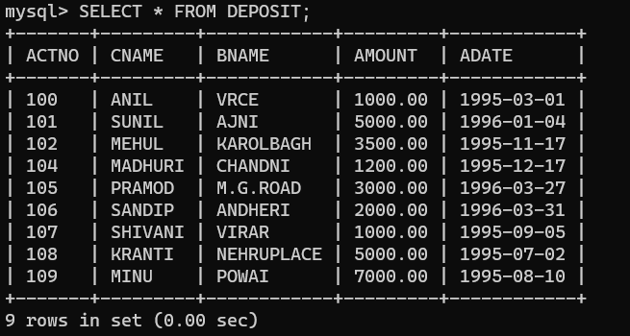

**QUERIES BASED ON SUBQUERIES:**

**QUERY (i):** Give name of customers whose branch is located in ‘DELHI’.

**OUTPUT:**

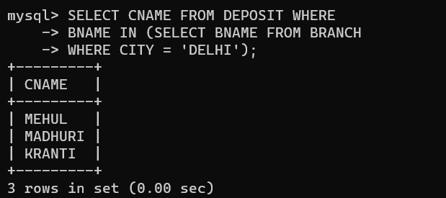

**QUERY (ii):** Give name of customers having loan amount more than that of ‘SUNIL’.

**OUTPUT:**

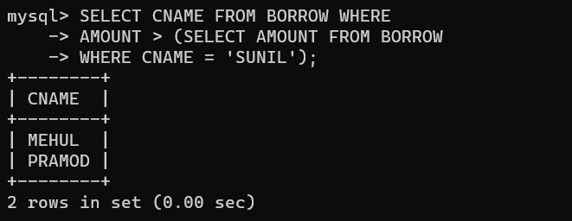

**QUERY (iii):** Give names of customers having deposit higher than the average deposit.

**OUTPUT:**

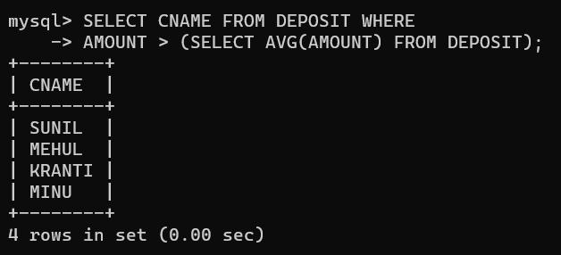

**QUERY (v):** Give the second highest deposit among depositors.

**OUTPUT:**

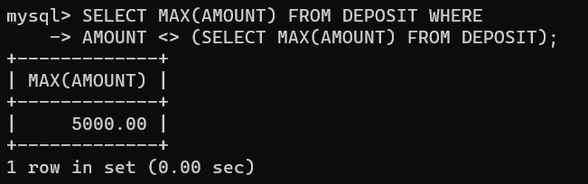

**QUERY (vi):** Give name of customers having living in same city as that of KRANTI.

**OUTPUT:**

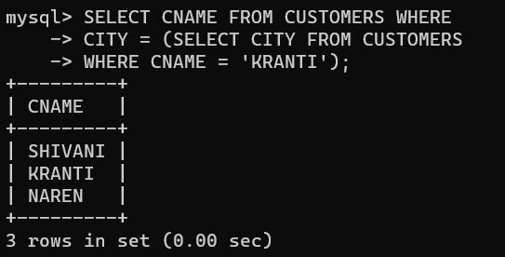

**QUERY (vii):** Give name of customers having higher deposit than PRAMOD.

**OUTPUT:**

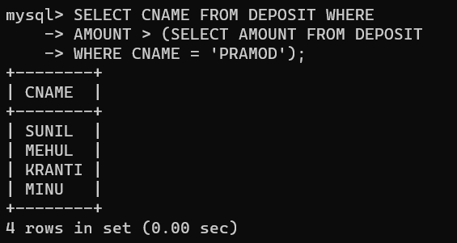

**QUERY (viii):** Give name of customers who are both depositors and borrowers and having deposit amount more than that of MEHUL.

**OUTPUT:**

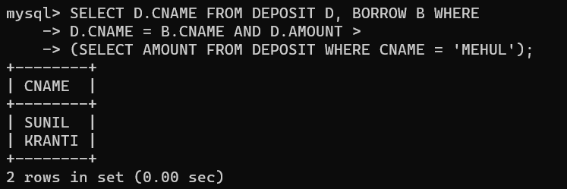

**QUERY (ix) :** Give name of customers who are depositors and having same branch city as that of SUNIL.

**OUTPUT:**

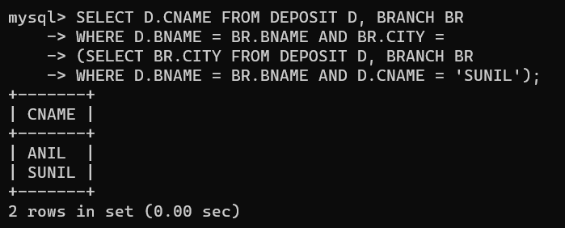

**QUERY (x):** Give deposit details and loan details of customer living in same city as that of PRAMOD.

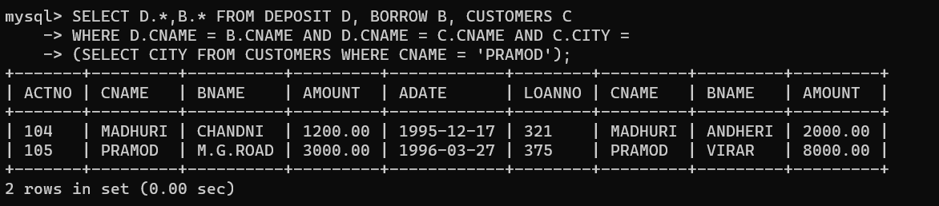**OUTPUT:**